Project Report

on
First Naukri – Job Portal
to be developed to fulfil the requirements for

Major Project (22CA015)

Submitted to
Department of Computer Applications Chitkara University, Punjab

under the supervision of
Dr. Harmaninder Jit Singh &
Dr. Arvinder Kaur

Submitted by

Urvi
2310997358
Swastik Arora
2310997293
Vanshika Chawla
2310997319

Bachelor of Computer Applications

(Batch 2023-26)

Certificate

This is to certify that the project titled “First Naukri – Job portal” is a bonafide work carried out by Urvi, Swastik Arora, Vanshika Chawla under our supervision during the academic year 2025–26.
This project work is submitted in partial fulfillment of the requirements for the award of the degree of Bachelor of Computer Applications (BCA).
To the best of our knowledge, this work is original and has not been submitted previously for any other degree or examination.

Guide 1 Name: Dr. Harmaninder Jit Singh
Signature:

Guide 2 Name: Dr. Arvinder Kaur
Signature:

Department: Bachelor of Computer Applications (BCA) College Name: Chitkara University

Table of Contents

- Abstract 1
- Profile of Problem 2
- Study of Existing System 3-4
- System Requirements
  - Product Definition
    - Problem Statement 5
    - Function to be provided 5
    - Processing Environment 6
    - Solution Strategy 7
    - Acceptance Criteria 7
  - Feasibility Analysis 8-9
  - Project Plan
    - Team Structure 10
    - Development Schedule 11
    - Programming Languages and Development Tools 12
- System Requirement Specifications
  - Developing / Operating / Maintenance Environments 13-14
  - External Interface and Data Flows 15-16
    - User display and report format, user command summary
    - High level DFD
    - Data dictionary
  - Functional and performance specifications 16
- Design
  - Detailed DFD’s and structure diagrams 17-22
  - Data structures, database and file specifications 23
  - Pseudo code 24-27
- Test Plan
  - Functional, Performance, Stress tests etc. 28-29
- Implementation / Conversion Plan 30-31
- Project Legacy
  - Current status of project 32
  - Remaining areas of concern 33
  - Technical and managerial lessons learnt 34
  - Future recommendations 34
- Bibliography 35
- Abstract

First Naukri – From Campus to Corporate is a web-based job portal system developed to bridge the gap between academic education and corporate employment. The platform is designed to provide a structured and intelligent recruitment environment that enables smooth interaction between graduating students and recruiters through a centralized digital system. The system implements a dual authentication mechanism that provides separate login modules for candidates and recruiters. Candidates can create and manage professional profiles, upload resumes, apply for job vacancies, track application status, and receive personalized job recommendations. Recruiters can create and manage company profiles, post and modify job openings, shortlist applicants, schedule interviews, and access recruitment analytics through a dedicated dashboard. The platform integrates an ATS-based Resume Analyzer, which evaluates resumes according to Applicant Tracking System standards. It generates an ATS score and provides improvement suggestions related to keyword optimization, formatting structure, and skill enhancement. Advanced job filtering and sorting mechanisms are implemented to allow users to search vacancies based on salary range, job type, location, experience level, company, and required skills. An AI-based recommendation engine is incorporated to suggest relevant job opportunities by analyzing resume content, profile data, and previous application behavior. Additional modules include an application tracking system, job alert notification system, company review and rating feature, profile strength meter, and an administrative control panel for managing users, job postings, and platform analytics. The system is developed using modern web technologies with emphasis on scalability, data security, performance optimization, and user experience. The primary target audience of the platform is graduating students and freshers seeking entry-level employment opportunities.

- Profile of problems assigned

In the current employment landscape, there exists a significant gap between academic education and corporate recruitment, particularly for graduating students and freshers. Despite the availability of multiple job portals, these platforms are often generalized and do not effectively cater to the specific needs of entry-level job seekers. Freshers frequently face challenges such as lack of industry exposure, limited awareness of job requirements, and difficulty in identifying suitable opportunities.
On the other hand, recruiters encounter difficulties in identifying appropriate candidates due to unstructured applicant data, high volume of applications, and lack of efficient filtering mechanisms. This leads to increased time and effort in the hiring process and reduces overall recruitment efficiency.
Additionally, most existing platforms do not provide features such as personalized job recommendations, application tracking, and skill-based job matching, which are important for improving the connection between job seekers and recruiters.
Therefore, the problem assigned in this project is to design and develop a centralized, intelligent, and user-friendly web-based job portal that specifically addresses the needs of freshers and recruiters. The system aims to streamline the recruitment process by integrating features such as dual user modules, AI-based job recommendations, advanced filtering, and application tracking, thereby reducing the gap between campus and corporate employment.
.

- Study of existing system

The current recruitment ecosystem is dominated by several online job portals such as LinkedIn, Indeed, and Glassdoor, which provide a wide range of job listings across industries, job roles, and experience levels. These platforms offer common features such as job search, resume upload, company profiles, application tracking, networking opportunities, and employer branding. They have significantly transformed traditional recruitment methods by making hiring faster, more accessible, and digitally driven. While these platforms are highly effective for experienced professionals and mid-level candidates, they present several limitations when it comes to catering specifically to freshers and entry-level job seekers.

One major limitation of existing systems is that they are generalized platforms, where job listings are not specifically tailored for fresh graduates. Most vacancies demand prior experience, specialized technical skills, or industry exposure, which many students and recent graduates may not possess. As a result, freshers often struggle to identify suitable opportunities and may face repeated rejection due to eligibility mismatches. The use of experience-based filters further reduces visibility of beginner-level opportunities for such candidates.

Another challenge is the high volume of job postings and applicants available on these platforms. Since thousands of jobs and applications are processed daily, freshers often find it difficult to shortlist relevant vacancies. New users may become overwhelmed by the number of options, leading to confusion, delayed decision-making, or missed opportunities. In many cases, deserving candidates are unable to gain recruiter attention because their profiles are lost among a large pool of applicants.

From the recruiter’s perspective, existing systems generate massive volumes of applications, many of which may not meet the required qualifications or skill criteria. Although filtering tools are available, they may not always provide accurate results for entry-level hiring. Recruiters often spend considerable time screening irrelevant or incomplete applications, which increases hiring costs and delays recruitment decisions. This problem is more noticeable when companies need to hire multiple freshers within limited time.
Furthermore, many current portals lack intelligent and personalized recommendation systems designed specifically for freshers. Job suggestions are often based on broad keywords or previous searches rather than actual academic background, skill level, interests, or potential. This reduces the effectiveness of matching the right candidate with the right opportunity and can lead to poor hiring outcomes.
Another limitation is the complexity of user interfaces, which may not be beginner-friendly for students who are using professional job portals for the first time. Complicated dashboards, excessive options, and unclear navigation may lead to confusion, incomplete profiles, or incorrect job applications. A lack of guidance during profile creation can further reduce the chances of being shortlisted.
Additionally, some platforms prioritize premium listings, paid promotions, or sponsored visibility, which may create unequal exposure among job seekers and employers. Small companies and freshers with limited resources may not benefit equally from such systems.
In summary, although existing job portals have modernized recruitment processes and offer valuable services, they still lack a focused, user-friendly, and intelligent environment specifically designed for freshers and campus hiring. These limitations highlight the need for a dedicated solution like First Naukri – From Campus to Corporate, which aims to provide simplified navigation, fresher-specific job opportunities, smart recommendations, and an efficient recruitment experience for both students and recruiters.

- System requirements
  - Product Definition
First Naukri – From Campus to Corporate is a web-based job portal system designed to provide a centralized platform for interaction between freshers and recruiters. The system enables efficient job searching, application management, and recruitment processes through a structured and user-friendly interface.
a) Problem Statement
Fresh graduates face significant challenges in finding suitable entry-level job opportunities due to lack of experience, limited exposure, and absence of dedicated platforms. At the same time, recruiters struggle to identify appropriate candidates from a large pool of applicants using existing generalized systems. Therefore, there is a need for a specialized job portal that simplifies the recruitment process and effectively connects freshers with recruiters.
b) Functions to be Provided
The system provides the following functionalities:
- User registration and secure login (Student & Recruiter)
- Student profile creation and management
- Job posting and management by recruiters
- Job search with filtering options (location, skills, job type, etc.)
- Online job application system
- Application tracking for students
- Applicant management for recruiters
- Job recommendation system
- Notification system for job updates

- Processing Environment
Hardware Requirements (H/W)
  - Processor: Intel i3 or higher / AMD equivalent
  - RAM: Minimum 4 GB (8 GB recommended)
  - Storage: At least 1 GB free disk space
  - Internet Connection: Required for accessing the web application and database (MongoDB Atlas)
  - Device: Laptop/Desktop (for development and usage)
Software Requirements (S/W)
  - Operating System: Windows, macOS, or Linux
- Frontend Technologies:
  - HTML, CSS, JavaScript
  - React.js (Vite)
- Backend Technologies:
  - Node.js
  - Express.js
- Database:
  - MongoDB Atlas (Cloud Database)
- Development Tools:
  - VS Code (Code Editor)
  - Postman (API testing)
  - MongoDB Compass)
- Browser Support:
  - Google Chrome, Edge, or any modern web browser

- Solution Strategy
The proposed system, First Naukri – From Campus to Corporate, is designed as a web-based application using a client-server architecture. The frontend is developed using React.js, while the backend is implemented using Node.js and Express.js. MongoDB Atlas is used as the database for efficient data storage and management.
The system implements secure authentication using JSON Web Tokens (JWT), and user passwords are encrypted using bcrypt to ensure data security. Role-based access control is applied to differentiate functionalities between students and recruiters.
The application is structured into modular components such as user management, job management, and application handling, which enhances scalability and maintainability..
- Acceptance Criteria
The system will be considered successfully implemented if the following criteria are met:
- Users (students and recruiters) can register and log in securely using valid credentials.
- Passwords are stored in encrypted form, and authentication is handled using JWT.
- Recruiters are able to post, update, and manage job listings.
- Students can view available jobs and apply for them successfully.
- The system correctly enforces role-based access control for different users.
- All data (users, jobs, applications) is stored and retrieved accurately from the database.
- Proper validation and error messages are displayed for invalid inputs or actions.
- The application runs smoothly without crashes and provides a responsive user interface.
  - Feasibility Analysis
The feasibility of the First Naukri – From Campus to Corporate system is evaluated to determine whether the project can be successfully developed, implemented, and maintained. Feasibility analysis helps in identifying the practicality of the proposed solution from technical, economic, and operational perspectives. Based on the study, the project is considered feasible and suitable for implementation.

i. Technical Feasibility
- The system is technically feasible as it uses widely available, modern, and well-supported technologies such as React.js, Node.js, Express.js, and MongoDB. These technologies are commonly used for web application development and provide strong community support, documentation, and scalability.
- React.js enables the creation of responsive and interactive user interfaces, while Node.js and Express.js provide an efficient backend environment for handling requests, authentication, and business logic. MongoDB offers flexible and scalable database management suitable for storing user profiles, job listings, and application data.
- The development tools required for the project, such as Visual Studio Code, GitHub, and web browsers, are easily accessible. Since the system is web-based, it can run on standard computers or laptops without requiring high-end hardware.
- Therefore, from a technical point of view, the project is practical, achievable, and capable of meeting future expansion requirements.

ii. Economic Feasibility
- The project is economically feasible because it relies mainly on open-source technologies and free development tools, which significantly reduce development costs. Frameworks such as React.js, Node.js, and Express.js are free to use, while MongoDB Atlas provides a free-tier cloud database service suitable for academic and small-scale deployment.
- The maintenance cost of the system is also low, as updates and modifications can be performed using the same technology stack. In the long term, the benefits of streamlined recruitment, reduced hiring time, and better employment opportunities outweigh the minimal development expenses.
- Hence, the project is cost-effective and economically viable.

iii. Operational Feasibility
- The system is operationally feasible because it is designed with a simple, user-friendly, and interactive interface suitable for both students and recruiters. Users with basic knowledge of web applications and internet usage can easily operate the platform.
- Students can register, create profiles, search for jobs, and apply through a guided process, while recruiters can post vacancies, manage applications, and monitor hiring activities through dedicated dashboards. The system reduces manual paperwork and simplifies communication between candidates and employers.
- As the platform is accessible through standard web browsers, users do not need any special training or additional software installation.
- Therefore, the proposed system is practical for day-to-day operations and highly acceptable to its intended users

  - Project plan
      - Team Structure

The project is developed by a small team (or individual developer) with clearly assigned roles to ensure smooth workflow and proper management of tasks. Dividing responsibilities improves productivity, reduces confusion, and allows better focus on each module of the system.
- Frontend Developer:
Responsible for designing and developing the user interface using React.js. This role includes creating responsive pages such as homepage, login/signup screens, student dashboard, recruiter dashboard, forms, and overall user experience.
- Backend Developer:
Handles server-side logic, API development, request handling, session management, and authentication using Node.js and Express.js. This role ensures proper communication between frontend and database.
- Database Manager:
Responsible for database design, data storage, retrieval, and management using MongoDB Atlas. This includes maintaining collections for users, job postings, applications, and ensuring data consistency.

b) Development Schedule
The development process is divided into multiple phases to ensure systematic execution of the project. Each phase focuses on specific objectives and deliverables.
- Phase 1: Requirement Analysis and Project Planning
Identification of project objectives, user requirements, scope, and system modules.
- Phase 2: UI/UX Design and Frontend Development
Designing wireframes, page layouts, navigation flow, and implementing frontend components using React.js.
- Phase 3: Backend Development and Database Integration
Creation of APIs, server-side logic, and connecting MongoDB database with the application.
- Phase 4: Implementation of Authentication and Core Features
Developing login/signup system, dashboards, job posting, job application, and user management modules.
- Phase 5: Testing and Debugging
Performing functional testing, fixing errors, validating workflows, and optimizing performance.
- Phase 6: Final Deployment and Documentation
Preparing final project files, deployment setup, user documentation, and report submission.

c) Programming Languages and Development Tools
The project is developed using modern web technologies and tools that support scalability, maintainability, and efficient development.

Programming Languages
- JavaScript – Used for both frontend and backend development
- HTML – Used for page structure and content
- CSS – Used for styling, layout, and responsive design

Frameworks & Libraries
- React.js – Frontend framework for dynamic user interface
- Node.js – Runtime environment for backend development
- Express.js – Web framework for API and server-side routing

Database
- MongoDB Atlas – Cloud-based NoSQL database for storing user and job-related data

Development Tools
- Visual Studio Code – Source code editor used for development
- Postman – API testing and request validation tool
- Git / GitHub – Version control and project collaboration
- Web Browsers – Chrome/Edge/Firefox for testing and debugging

- System Requirement Specifications

a. Developing / Operating / Maintenance Environments
The successful functioning of the First Naukri – From Campus to Corporate system depends on suitable development, operating, and maintenance environments. These environments ensure efficient development, smooth execution, and long-term sustainability of the application.
- Development Environment
The system is developed using modern web development tools and technologies that support rapid development, testing, and scalability.
- Visual Studio Code is used as the primary source code editor for writing and managing project files.
- React.js is used for frontend development to build responsive and interactive user interfaces.
- Node.js provides the runtime environment for executing server-side JavaScript.
- Express.js is used for backend routing, API creation, and request handling.
- MongoDB Atlas is used as the cloud-based database for storing user profiles, job listings, and applications.
- Postman is used for API testing and validation during backend development.
- Git and GitHub are used for version control, source code backup, and collaboration.
This environment enables efficient coding, debugging, and module integration throughout the development lifecycle.
- Operating Environment
The deployed application operates as a web-based platform and can be accessed through standard internet-enabled devices.
- Compatible web browsers include:
  - Google Chrome
  - Microsoft Edge
  - Mozilla Firefox
  - Safari
- Supported operating systems include:
  - Windows
  - macOS
  - Linux
- Hardware requirements:
  - Computer/Laptop with minimum 4 GB RAM
  - Stable internet connection
Since the application is browser-based, users are not required to install special software, making the system easily accessible to students and recruiters.
• Maintenance Environment
The system is designed using a modular architecture, which simplifies maintenance, upgrades, and troubleshooting.
- Git is used to track changes, manage versions, and restore previous code when required.
- Bugs and errors can be identified and fixed efficiently without affecting the entire system.
- New features such as AI recommendations, notifications, or analytics modules can be integrated in future versions.
- Regular database backup and monitoring can be performed to ensure data safety and reliability.
- Performance optimization and security updates can be applied periodically.
This maintenance environment ensures that the system remains stable, secure, and adaptable to future requirements.
  - External Interface and Data Flows

- User Display and Report Format, User Command Summary
- The system provides a user-friendly interface with clear navigation for both students and recruiters.
- Users interact through forms such as registration, login, job posting, and job application forms.
- Outputs include job listings, application status, and user profiles displayed in structured formats.
- Commands include actions like login, register, post job, apply for job, and logout.
- High Level DFD
The system consists of two main entities: Users (Students/Recruiters) and the System Server.
- Users send requests (login, job search, job posting).
- The server processes requests and interacts with the database.
- The database stores user data, job details, and applications.
- The server sends responses back to users.
- Data Dictionary:
  - User: user_id, name, email, password, role
  - Job: job_id, title, description, company, location
  - Application: application_id, user_id, job_id, status
  - Functional and Performance Specifications
- Functional Specifications:
  - User registration and login functionality
  - Role-based access (student/recruiter)
  - Job posting and management by recruiters
  - Job search and application by students
  - Secure authentication and data handling
- Performance Specifications:
  - The system should respond to user requests within a few seconds
  - It should handle multiple users simultaneously without performance degradation
  - Data retrieval and storage should be efficient and reliable
  - The system should ensure minimal downtime and smooth operation

- Design
  - Data Flow Diagram

- The DFD represents how data moves through your system.
Level 0 represents the entire system as a single process and shows the external entities that interact with it.
- The Level 1 DFD breaks the system into major functional processes and identifies the primary data stores (Login, Job Seeker info, Employer info, and Job info)
- Level 2 DFDs provide a deep dive into the specific logic of the registration and search modules.
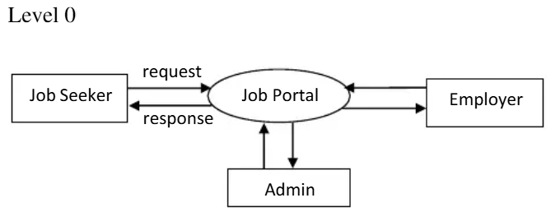

- Level 0 DFD
The Level 0 DFD represents the overall working of the First Naukri Job Portal System as a single process.
The system interacts with three external entities:
- Job Seeker (Student): Sends job search requests and receives job listings and application status.
- Employer (Recruiter): Sends job posting details and receives applicant information.
- Admin: Monitors and manages the system activities.
Data Flow:
- Job seekers send requests (search/apply) and receive responses (job results/status).
- Employers send job details and receive applications.
- Admin controls and monitors system operations.
This level provides a high-level overview of how users interact with the system.

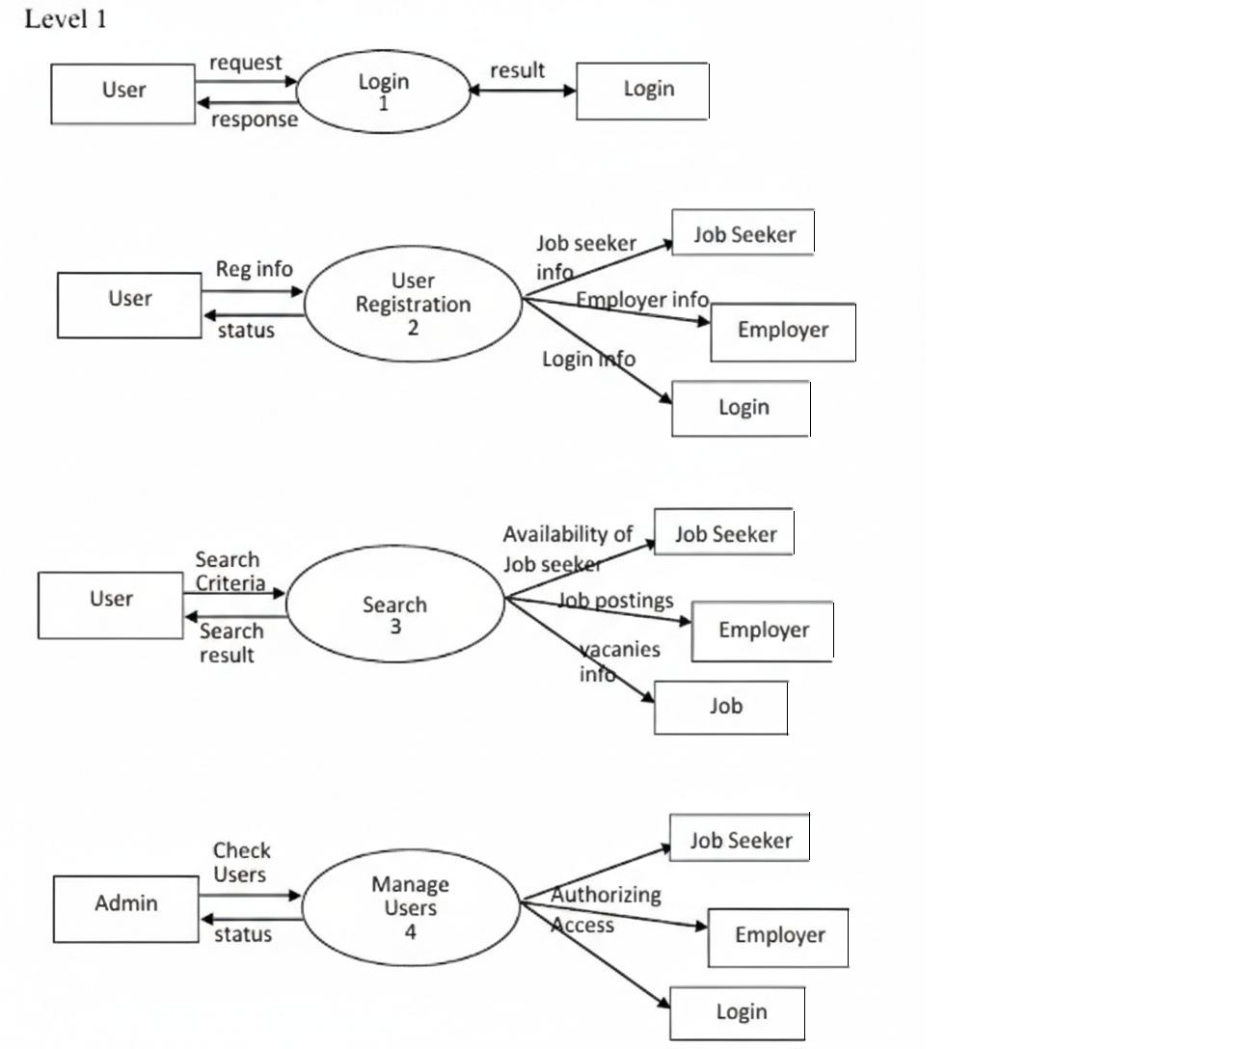

- Level 1 DFD
The Level 1 DFD breaks down the system into major functional modules:
1. Login Process
- The user sends login credentials.
- The system verifies details from the Login database.
- Returns login result (success/failure).
2. User Registration
- Users provide registration information.
- Data is stored separately as:
  - Job Seeker information
  - Employer information
- Login credentials are also created.
- System returns registration status.
3. Search Process
- Users enter search criteria.
- The system fetches:
  - Job seeker availability
  - Job postings
  - Vacancy information
- Returns search results.
4. Manage Users (Process 4)
- Admin checks and manages users.
- Provides authorization and access control.
- Updates system status.
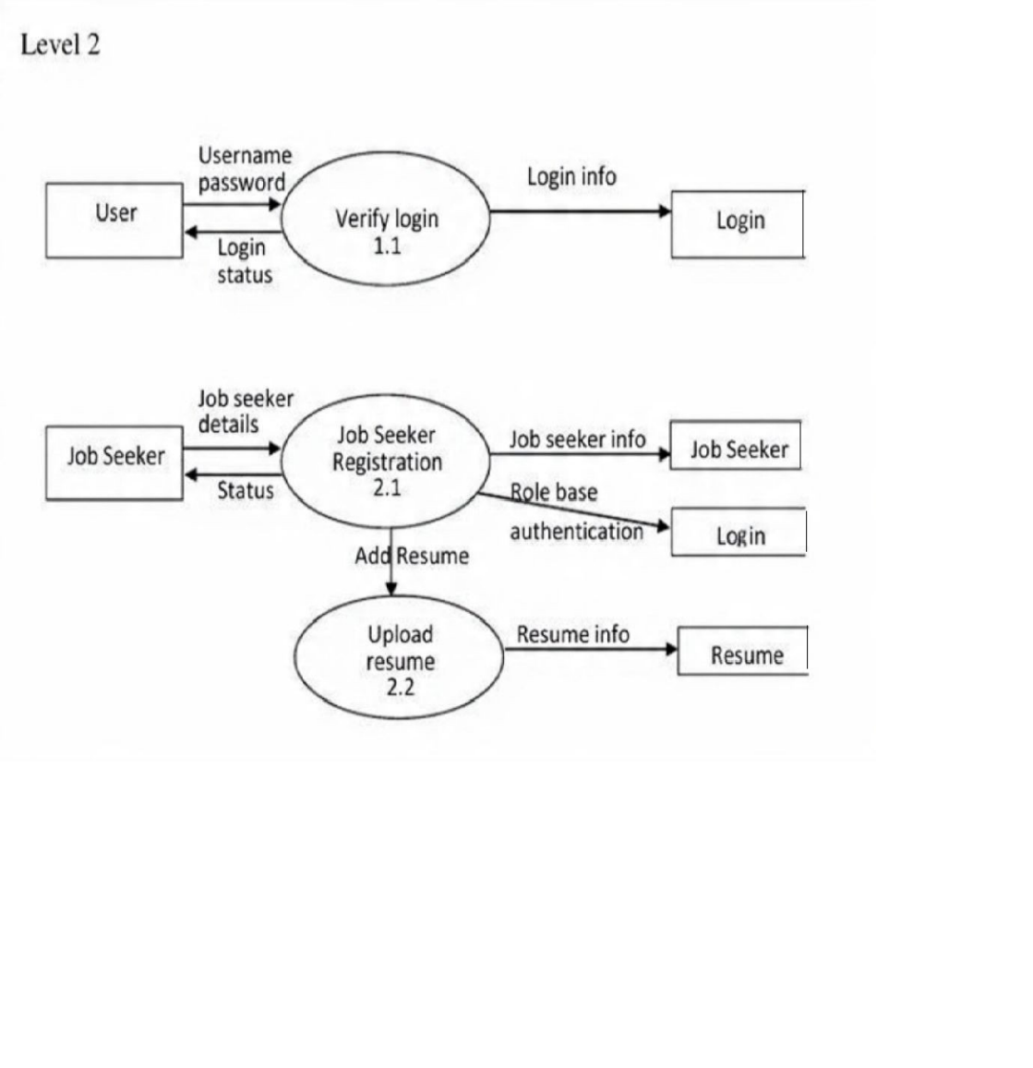

- Level 2 DFD
Level 2 gives a more detailed breakdown of each module:
1. Verify Login (1.1)
- User enters username and password.
- System validates credentials with the login database.
- Outputs login status.
2. Job Seeker Registration (2.1)
- Job seeker enters personal details.
- Information is stored in the database.
- Role-based authentication is applied.
3. Upload Resume (2.2)
- Job seeker uploads resume.
- Resume data is stored separately.

4. Employer Registration (2.3)
- Employer enters company details.
- Data is stored in employer database.
- Authentication is created.
5. Publish Jobs (2.4)
- Employer posts job vacancies.
- Job details are stored in the job database.
6. Search Job Vacancy (3.1)
- Job seeker searches using filters.
- System retrieves job and company information.
- Displays results.
7. Search Applicants (3.2)
- Employer searches candidates.
- System provides applicant details.
  - Data structures, database and file specifications
    - Data Structures:
The system uses structured data to manage users, jobs, and applications efficiently. The key data structures are:
a. User Structure
- user_id (Primary Key)
- name
- email
- password
- role (Job Seeker / Employer / Admin)
- contact_number
b. Job Seeker Structure
- user_id (Foreign Key)
- education
- skills
- experience (if any)
- resume_link
c. Employer Structure
- user_id (Foreign Key)
- company_name
- company_description
- location
d. Job Structure
- job_id (Primary Key)
- employer_id (Foreign Key)
- job_title
- job_description
- location
- salary
- job_type
- required_skills
- date_posted
e. Application Structure
- application_id (Primary Key)
- user_id (Foreign Key)
- job_id (Foreign Key)
- status (Applied / Selected / Rejected)
- applied_date

    - Database Specifications
The system uses a relational database (MySQL/MongoDB equivalent) to store and manage data.
Main Tables
Users Table
Field Name | Type | Description
user_id | INT (PK) | Unique user ID
name | VARCHAR | User name
email | VARCHAR | Login email
password | VARCHAR | Encrypted password
role | VARCHAR | Student / Employer / Admin

Job_Seeker Table
Field Name | Type | Description
user_id | INT (FK) | Linked to Users
education | VARCHAR | Qualification
skills | TEXT | Skill set
experience | VARCHAR | Experience level

Employer Table
Field Name | Type | Description
user_id | INT (FK) | Linked to Users
company_name | VARCHAR | Company name
location | VARCHAR | Company location

Jobs Table
Field Name | Type | Description
job_id | INT (PK) | Unique job ID
employer_id | INT (FK) | Recruiter ID
title | VARCHAR | Job title
description | TEXT | Job details
location | VARCHAR | Job location

Applications Table
Field Name | Type | Description
application_id | INT (PK) | Unique ID
user_id | INT (FK) | Applicant ID
job_id | INT (FK) | Job ID
status | VARCHAR | Applied/Selected/Rejected
applied_date | DATE | Date of application

    - File Specifications
- Frontend Files
- HTML files (structure of web pages)
- CSS files (styling and layout)
- JavaScript files (client-side logic)
- Backend Files
- Server-side scripts (Node.js / Python)
- API files for handling requests
- Authentication modules
- Database Files
- Tables storing users, jobs, applications
- Managed through MySQL/MongoDB
- User Uploaded Files
c. Pseudo Code
1. User Registration
START
INPUT user details (name, email, password, role)
IF email already exists in database THEN
DISPLAY "User already registered"
ELSE
STORE user details in Users table
IF role = "Job Seeker" THEN
STORE additional details in Job_Seeker table
ELSE IF role = "Employer" THEN
STORE company details in Employer table
ENDIF
DISPLAY "Registration Successful"
ENDIF
END
2. User Login
START
INPUT email and password
SEARCH user in database
IF user exists AND password matches THEN
IF role = "Job Seeker" THEN
REDIRECT to Student Dashboard
ELSE IF role = "Employer" THEN
REDIRECT to Recruiter Dashboard
ELSE
REDIRECT to Admin Panel
ENDIF
ELSE
DISPLAY "Invalid Credentials"
ENDIF
END
3. Job Posting (Employer)
START
INPUT job details (title, description, location, salary, skills)
VALIDATE input fields
IF all fields are valid THEN
STORE job in Jobs table
DISPLAY "Job Posted Successfully"
ELSE
DISPLAY "Error in Job Posting"
ENDIF
END
4. Job Search (Student)
START
INPUT search criteria (location, skills, job type)
FETCH jobs from database matching criteria
IF jobs found THEN
DISPLAY job list
ELSE
DISPLAY "No jobs found"
ENDIF
END
5. Job Application
START
USER selects a job
CLICK "Apply"
CHECK if user already applied
IF already applied THEN
DISPLAY "Already Applied"
ELSE
STORE application in Applications table
SET status = "Applied"
DISPLAY "Application Submitted Successfully"
ENDIF
END
6. View Applications (Employer)
START
EMPLOYER selects a job
FETCH all applications for that job
DISPLAY applicant details
END
7. Update Application Status
START
EMPLOYER selects applicant
UPDATE status (Selected / Rejected)
SAVE changes to database
DISPLAY "Status Updated"
END

- Test Plan
The purpose of testing is to ensure that the First Naukri job portal functions correctly, efficiently, and reliably under different conditions. Various types of testing are performed to validate system behavior and performance.
a. Functional Testing
Functional testing verifies that all features of the system work as expected.
Test Case | Description | Expected Result
User Registration | Enter valid user details | User registered successfully
User Login | Enter correct credentials | Login successful
Invalid Login | Enter wrong password | Error message displayed
Job Posting | Recruiter posts job | Job saved in database
Job Search | Student searches jobs | Relevant jobs displayed
Job Application | Student applies for job | Application stored successfully
View Applications | Recruiter views applicants | Applicant list displayed

b. Performance Testing
Performance testing checks system speed and responsiveness.
System loads pages within acceptable time
Handles multiple users simultaneously
Quick response during job search and application
Efficient database retrieval.
Expected Outcome:
System performs smoothly without delays under normal usage.

c. Stress Testing
Stress testing evaluates system behavior under extreme conditions.
Large number of users accessing system simultaneously
High volume of job postings and applications
Continuous usage over extended time
Expected Outcome:
System remains stable or fails gracefully without data loss.

d. Usability Testing
Interface is easy to understand
Navigation is simple for new users
Forms are user-friendly.

e. Security Testing
Passwords are protected
Unauthorized access is restricted
User data is stored securely

- Implementation / Conversion Plan
The implementation of the First Naukri – Web-Based Job Portal involves the systematic development, integration, testing, and deployment of the system. The goal is to ensure a smooth transition from development to actual usage by end users.
a. Implementation Approach
The project follows a modular development approach, where different components of the system are developed and tested separately before integration.
Steps involved:
- Design of user interface (Homepage, Login, Dashboards)
- Development of frontend using HTML, CSS, and JavaScript
- Backend development for handling logic and requests
- Database design and integration
- Testing of individual modules
- Integration of all modules into a complete system

b. System Implementation
The system is implemented as a web-based application:
- Users access the system through a web browser
- Frontend handles user interaction
- Backend processes data and communicates with the database
- Database stores user, job, and application data

c. Conversion Strategy
Since this is a new system (no existing system replacement), the Direct Conversion Method is used.
- The system is developed and tested independently
- After successful testing, it is deployed for users
- Users directly start using the new system

d. Deployment Plan
- Host the application on a web server (local or cloud)
- Connect the system with the database server
- Ensure proper configuration of backend services
- Make the system accessible via browser

e. User Training
- Basic instructions provided for students and recruiters
- Simple and user-friendly interface reduces training need
- Guidance for login, job search, and job posting

f. Maintenance Plan
- Regular bug fixing and updates
- Database backup and security checks
- Performance monitoring
- Feature enhancements in future

- Project Legacy
a. Current Status of Project
The First Naukri – Web-Based Job Portal has been successfully developed with the major core functionalities implemented. The project has reached a stable working stage where primary modules are integrated and operational. The current version of the system includes:
- Homepage with structured navigation and user-friendly layout
- User registration and secure login system for both Students and Recruiters
- Student dashboard with profile management, job search, and job application features
- Recruiter dashboard for posting vacancies and viewing applicants
- Database integration for storing users, job listings, and applications
- Basic validation and functional testing of major modules
The system is functional and has been tested for standard operations under normal usage conditions.

b. Remaining Areas of Concern
Although the major features of the system are working successfully, certain areas still require enhancement for future versions and production-level deployment.
- Advanced job filtering and smart recommendation features can be improved
- UI/UX design can be enhanced for smoother navigation and modern appearance
- Security mechanisms such as advanced encryption and multi-factor authentication can be added
- Scalability for handling a large number of simultaneous users requires optimization
- Performance tuning can be done for faster search and response time
- Additional testing under heavy load conditions can be performed
These improvements will help transform the system into a more robust and enterprise-ready platform.
c. Technical and Managerial Lessons Learnt
The development of this project provided valuable technical as well as managerial learning experiences.
Technical Lessons:
- Understanding of full-stack web development concepts
- Frontend development using React.js
- Backend API development using Node.js and Express.js
- Database design, CRUD operations, and integration using MongoDB
- Debugging, error handling, and issue resolution
- Importance of testing, validation, and performance optimization
- Real-world implementation of authentication systems
Managerial Lessons:
- Team coordination and effective task distribution
- Time management during different development phases
- Planning and execution according to deadlines
- Problem-solving under technical constraints
- Importance of communication and collaboration
- Value of proper documentation and version control

d. Future Recommendations
The system has strong potential for further development and enhancement. Recommended future improvements include:
- Implementation of AI-based job recommendation system
- Development of Android / iOS mobile application
- Integration of email and SMS notification system
- Advanced recruiter analytics and hiring reports
- Resume screening and profile matching system
- Enhanced security and data privacy mechanisms
- Real-time chat between recruiters and candidates
- Integration with college placement cells and campus drives

10. Bibliography
- W3Schools (2025) HTML, CSS and JavaScript Tutorials. Available at: https://www.w3schools.com (Accessed: 12 February 2026).
- Mozilla Developer Network (MDN) (2025) Web Development Documentation. Available at: https://developer.mozilla.org (Accessed: 25 February 2026).
- Node.js Foundation (2025) Node.js Documentation. Available at: https://nodejs.org (Accessed: 10 March 2026).
- Django Software Foundation (2025) Django Documentation. Available at: https://docs.djangoproject.com (Accessed: 18 March 2026).
- MongoDB Inc. (2025) MongoDB Documentation. Available at: https://www.mongodb.com/docs (Accessed: 28 March 2026).
- Oracle Corporation (2025) MySQL Documentation. Available at: https://dev.mysql.com/doc (Accessed: 5 April 2026).
- GitHub (2025) Version Control and Collaboration Platform. Available at: https://github.com (Accessed: 9 April 2026).
- Naukri.com (2025) Online Job Portal. Available at: https://www.naukri.com (Accessed: 15 February 2026).
- LinkedIn Corporation (2025) LinkedIn Job Platform. Available at: https://www.linkedin.com (Accessed: 22 March 2026).
- Indeed (2025) Job Search Platform. Available at: https://www.indeed.com (Accessed: 2 April 2026).

